Karnataka Law Society’s

GOGTE INSTITUTE OF TECHNOLOGY

Department of Computer Science and Engineering

Udyambag Belagavi -590008

Karnataka, India.



Internship Report on

# TITLE: “Core Java”

# *Submitted in the partial fulfillment for the award of the degree of*

# Bachelor of Engineering

# In

# Information Science and Engineering “INTERNSHIP (18IS81)”

*Submitted by*

|  |  |
| --- | --- |
| USN | Name of Candidate |
| 2GI19IS024 | Megha Magadumakar |

**Internal Guide External Guide**

Prof. R. J. Kadkol Kokila Gopinath

Academic Year 2022-2023

Karnataka Law Society’s

GOGTE INSTITUTE OF TECHNOLOGY

Department of Computer Science and Engineering

Udyambag Belagavi -590008

Karnataka, India.

**DEPARTMENT OF INFORMATION SCIENCE AND ENGINEERING**



**CERTIFICATE**

This is to certify that **MEGHA MAGADUMAKAR** of **8th** semester and bearing **USN:2GI19IS024** has satisfactorily completed the Internship entitled **“Core Java”** done at ***Milestone First Step To Job*.** It can be considered as a bonafide work carried out in partial fulfillment for the academic requirement of 8thSemester B.E. **(INFORMATION SCIENCE AND ENGINEERING**) prescribed by KLS Gogte Institute of Technology, Belagavi during the academic year **2022- 2023**.

Signature of the Faculty Member Signature of the HOD

Date:

**Internship Completion Certificate:**

**ACKNOWLEDGEMENT**

The successful completion of task would be incomplete without complementing those who made it possible and whose guidance and encouragement made my efforts successful. The internship would not have been possible if I did not have received support of many individuals and organizations for their incredible knowledge. Therefore, I would like to extend my sincere gratitude to all of them. In particular, I would like to take this opportunity to express my honor, respect, deep gratitude & genuine regards to the staff of **Milestone Internship First Step to Job, Bangalore** for providing me all the guidance required for the completion of the internship.

I sincerely would like to thank my guide **Durga Laxmi Madam** for guiding me throughout this internship.

I sincerely would also like to express my deep gratitude and thankfulness to **Mrs. Kokila Gopinath** - Founder & Director for providing me an excellent opportunity of internship at “Milestone First step to Job” without which my work would not have been completed.

Last but not the least I would like to thank all the people who have helped me directly and indirectly for making my internship work successful.

**Megha Magadumakar**

2GI19IS024

B.E. (ISE)

**ABSTRACT**

This project report describes our work for the development of “**Accounting System**” for the organization **Milestone First Step to Job**. The Milestone Accounting System is a web application built for the internal usage of the company in the accounting department. The software becomes in easy tool for the accounts department to record and store data in the database in digital format, this software also provides required data to be entered specific to the company which help in the ease of usage since it is tailor made for the company itself,

In this Web application, the user(admin) can enter the different form of data which has to be stored. The data entered can be of either a payment made or received. He/She can also add details the payment related to the company, including the salaries paid to the employees. The user can add or delete an employee based upon their tenure of working to make sure the ID is not reused for any other payments.

The user can also view all the payments made and received in the form of a data table and view the statistics accordingly. Which help the team to identify a payment easily. The project “**Accounting System**” is developed with the objective of making the system reliable, easier, fast, and more informative.

**CONTENTS**

1. **INTRODUCTION**
2. **Organization Profile…………………………………………….…..….………07**
3. **Introduction of Project……………………………………………..…….…….08**
4. **Problem Specification………………………………………………..….……...09**
5. **Problem Definition……………………………………………………...………09**
6. **Objective of Project……………………………………………………..……...09**
7. **SYSTEM REQUIREMENTS**
8. **Hardware and Software Requirements………………………………..……...10**
9. **DEVELPOMENT ENVIRONMENT**
10. **Introduction to Java……………………………………………………..……..10**
11. **Introduction to Oracle Database……………………………………….….…..12**
12. **Introduction to Tomcat server….…………………………………………..….13**
13. **SYSTEM DESIGN**
14. **Modular Description……………………………………………………...…….14**
15. **PROJECT OVERVIEW**
16. **Implementation / Screenshots…………….……………………………...…….15**
17. **CONCLUSION…………………………………………………………………..….17**
18. **REFERENCE……………………………………………………………………….18**
19. **INTRODUCTION**
20. **ORGANISATION PROFILE:**



Milestone is an initiative and is just an infant with a thought to spread awareness to the young candidates who are coming out of college aiming for an IT Career. We are a team of professionals having vivid experience in various sectors such as IT, Communication and Counselling industry more than a decade and all of us have come together to help, guide and lay a foundation for the young minds to decide and achieve their aspiring IT careers, which they are good at with a zeal of confidence. Our focus is on our understanding and belief that every candidate is unique in their own skill ,which has to be recognized and groomed according to the industry needs.

Website : <https://www.milestonefstjob.com>

Phone : 9380001850

Industry : Professional Training and Coaching

Headquarters : Bangalore, Karnataka

Founded : 2018

1. **INTRODUCTION OF PROJECT**

A website is a collection of web pages and related content that is identified by a domain name. Websites are the most significant providers of information in this era of technology. For any business, a website serves as its very own salesperson it displays what any consumer would want to see, such as products, services, support, etc. Moreover, with the ever-growing technology monetary transactions are now safe, efficient, and convenient.

A website is commonly the user's first impression of the brand, be it a company website, the website for an educational institute, or simply an informative website. The first place to land while researching an organization online is its respective website. Therefore, the importance of a website cannot be overstated. The look of a website, the ease of navigation, proper display of relevant information is all important features that must be considered while creating a website.

The Milestone Accounting System is a web application built for the internal usage of the company in the accounting department. The software becomes in easy tool for the accounts department to record and store data in the database in digital format, this software also provides required data to be entered specific to the company which help in the ease of usage since it is tailor made for the company itself.

In this Web application, the user(admin) can enter the different form of data which has to be stored. The data entered can be of either a payment made or received. He/She can also add details the payment related to the company, including the salaries paid to the employees. The user can add or delete an employee based upon their tenure of working to make sure the ID is not reused for any other payments.

The user can also view all the payments made and received in the form of a data table and view the statistics accordingly. Which help the team to identify a payment easily.

This project include:

1. Login and Signup options for the employee.

2. Saving details of the user in the database.

3. Develop Payment System for employees and trainees.

4. Giving choice to the employees to perform different crude operation on employee data.

5. View salaries paid to the employees.

1. **PROBLEM SPECIFICATION:**

This problem is assigned to me during my core java training to design an application on “**Accounting System**” for the internal use at accounting department of organization using **Java** and **Oracle database**.

1. **PROBLEM DEFINITION**

This project works by storing the details of trainees and employees in the database and then providing secured authentication system for users. System should validate users. System should provide payment form of trainees, data will stored into database. Enable to change payment status. System also provide different menus to manage employee’s details about payment related to the company, including the salaries paid to the employees. . The user can add or delete an employee based upon their tenure of working to make sure the ID is not reused for any other payments.

With help of this system user can also view all the payments made and received in the form of a data table and view the statistics accordingly.

1. **OBJECTIVES OF PROJECT:**
2. The objective of Accounting System is to automate internal operations of accounting department in organization.
3. This software helps accounts department to record and store data in the database in digital format.
4. This software will provide required data to be entered specific to the company which help in the ease of usage.
5. Save cost After computerized system is implemented less human force will be required to maintain the library thus reducing the overall cost.
6. Save time of staff, is able to search record by using few clicks of mouse and few search keywords thus saving his valuable time.
7. This software will reduce manual error and validate user and is also bug free.
8. The system contain database where all the information will be stored safely.
9. **SYSTEM REQUIREMENTS**
10. **HARDWARE AND SOFTWARE REQUIREMENTS**

* **HARDWARE REQUIREMENT: -**
* Processor : Intel core processor or better performance
* RAM : 1 GB RAM or more
* Hard disk space : Minimum 3 GB for database usage for future
* Keyboard & Mouse
* **SOFTWARE REQUIREMENTS: -**
* Operating System: WINDOWS11
* Front-End: JAVA EE
* Back-End: oracle database - MySQL

1. **DEVELPOMENT ENVIRONMENT**
2. **FRONT END**

**INTRODUCTION TO JAVA**

Java is an object-oriented programming language originally developed by Sun Microsystems and released in 1995.

* Java was originally developed by James Gosling at Sun Microsystems (which has since merge into Oracle Corporation).
* Java programs are platform independent which means they can be run on any operating system with any type of processor as long as the Java interpreter is available on that system.
* Java code that runs on one platform does not need to be recompiled to run on another platform, it’s called “write once, run anywhere” (WORA).
* Java virtual machine (JVM) executes Java code, but is written in platform specific languages such as C/C++/ASM etc. JVM is not written in Java and hence cannot be platform independent and Java interpreter is actually a part of JVM.

**USES OF JAVA**

Earlier, java was only used to design and program small computing devices but later adopted as one of the platform independent programming languages and now according to Sun, 3 billion devices run java. Java is one of the most important programming languages in today’s IT industries.

* JSP – Java is used to create web applications like PHP and ASP, JSP (Java Server Pages) used with normal HTML tags, which helps to create dynamic web pages.
* Applets – This is another type of Java program that used within a web page to add many new features to a web browser.
* J2EE – The software Java 2 Enterprise Edition are used by various companies to transfer data based on XML structured documents between one another.
* JavaBeans – This is something like Visual Basic, a reusable software component that can be easily assemble to create some new and advanced application.
* Mobile – Besides the above technology, Java is also used in mobile devices, many kind of games and services built in Java. Today, all leading mobile service provider like Nokia, Siemens, Vodafone are using Java technology.

**JAVA APPLICATIONS**

* Web Application Java is used to create server side web applications. Currently, servlet, jsp, struts, jsf etc. technologies are used.
* Standalone Application It is also known as desktop application or window-based application. An application that we need to install on every machine or server such as media player, antivirus etc. AWTand Swing are used in java for creating standalone applications.
* Enterprise Application An application that is distributed in nature, such as banking applications etc. It has the advantage of high level security, load balancing and clustering. In java, EJB is used for creating enterprise applications.
* Mobile Application Java is used to create application software for mobile devices. Currently Java ME is used for creating applications for small devices, and also Java is programming language for Google Android

1. **BACK END**

**INTRODUCTION TO ORACLE DATABASE**

An Oracle database is a collection of data treated as a unit. The purpose of a database is to store and retrieve related information. A database server is the key to solving the problems of information management. In general, a server reliably manages a large amount of data in a multiuser environment so that many users can concurrently access the same data. All this is accomplished while delivering high performance. A database server also prevents unauthorized access and provides efficient solutions for failure recovery.

Oracle Database is the first database designed for enterprise grid computing, the most flexible and cost effective way to manage information and applications. Enterprise grid computing creates large pools of industry standard, modular storage and servers. With this architecture, each new system can be rapidly provisioned from the pool of components. There is no need for peak workloads, because capacity can be easily added or reallocated from the resource pools as needed.

The database has logical structures and physical structures. Because the physical and logical structures are separate, the physical storage of data can be managed without affecting the access to logical storage structures.

**MYSQL-**

MySQL ("My S-Q-L", officially, but also called "My Sequel") is (as of July 2013) the world's second most widely used open-source relational database management system (RDBMS). It is named after co-founder Michael Widenius daughter, My. The SQL phrase stands for Structured Query Language. The MySQL development project has made its source code available under the terms of the GNU General Public License, as well as under a variety of proprietary agreements. MySQL was owned and sponsored by a single for-profit firm, the Swedish company MySQL AB, now owned by Oracle Corporation. MySQL is a popular choice of database for use in web applications, and is a central component of the widely used LAMP open-source web application software stack (and other 'AMP' stacks). LAMP is an acronym for "Linux, Apache, MySQL, Perl/PHP/Python." Free-software-open-source projects that require a full-featured database management system often use MySQL. For commercial use, several paid editions are available, and offer additional functionality.

Applications which use MySQL databases include: TYPO3, MODx, Joomla, WordPress, phpBB, MyBB, Drupal and other software. MySQL is also used in many high-profile, large-scale websites, including Wikipedia, Google (though not for searches), Facebook, Twitter, Flickr, and YouTube.

1. **APACHE TOMCAT SERVER**

**INTRODUCTION TO TOMCAT:**

It is an open-source Java servlet container that implements many Java Enterprise Specs such as the Websites API, Java-Server Pages and last but not least, the Java Servlet. The complete name of Tomcat is "Apache Tomcat" it was developed in an open, participatory environment and released in 1998 for the very first time. It began as the reference implementation for the very first Java-Server Pages and the [Java Servlet](https://www.javatpoint.com/servlet-tutorial) API. However, it no longer works as the reference implementation for both of these technologies, but it is considered as the first choice among the users even after that. It is still one of the most widely used java-sever due to several capabilities such as good extensibility, proven core engine, and well-test and durable. Here we used the term "servlet" many times, so what is [java](https://www.javatpoint.com/java-tutorial) servlet; it is a kind of software that enables the webserver to handle the dynamic(java-based) content using the Http protocols.

**APACHE TOMCAT:**

If you want to provide any web-services such as you want to provide a simple static content possibly by using [HTML](https://www.javatpoint.com/html-tutorial) (or Hypertext Markup Language), or maybe you just want to send data from a server to point you, so you necessarily need a server and that server is [HTTP](https://www.javatpoint.com/http-full-form)(Hyper Text transfer protocol). So, as we all know that if anyone wants to make a simple, static website, he definitely requires an [HTTP](https://www.javatpoint.com/http-tutorial) server, but if he wants to make website dynamic, he has to use servlet. We use the HTTP server if we want to send simple data. If we want to send dynamic data or to make our website dynamic, we need to use the servlet. Hence, we need an HTTP server and what else we need is a container where we will run or servlet, so when we combine the [HTTP](https://www.javatpoint.com/computer-network-http) server and the servlet (or we can say servlet container), they both combine to become a single server know as tomcat server.

The Java ecosystem supports a wide variety of application servers, so let's have a little discussion on each of them and see where Tomcat fits in:

A servlet container is basically an implementation of the Java servlet specification, which is mainly used for the purpose of hosting Java servlets. The Java enterprise application-server is an implementation of the Java specification. A web- server is a kind of server designed to serve files using a local system such as Apache.

We can say that, the Tomcat is [JSP (Java Server Pages)](https://www.javatpoint.com/jsp-tutorial) and Servlet. The JSP is one of the server-side programming technologies that enables the developers to create platform-independent dynamic content and also known as the server-side view rendering technology. A servlet is a java-based software component that helps in extending the capabilities of a server. However, it can also respond to several kinds of requests and generally implemented web server containers to host the web-applications on the webservers. As the developer's point of view, we just have to write the java server pages (or JSP) or the servlet and not required to worry about routing; the Tomcat will handle the routing.

1. **SYSTEM DESIGN**

**MODULAR DESCRIPTION**

1. **Login And Registration :**

In this module new employee or user requires to enter his/her all details that’s has been asked to enter in signup form. No field be remain unfilled. All these details get stored in the database, for each employee details can be accessed further for authentication.

1. **Trainee Payment Form:**

This is the module that belong to “Trainee’s details” which will be filled by employees of organization to get register and update details about trainees of their organization. This arrangement for get to know about details about interns enrolled in the organization and calculate payment amount received from internships which will help for internal operations accounting department.

1. **Employee Payment Form:**

This is the module that belong to “Employee’s details” which will be filled by employees of organization. Accounting team will use this module to add details the payment related to the company, including the salaries paid to the employees. The user can add or delete an employee based upon their tenure of working to make sure the ID is not reused for any other payments.

The user can also view all the payments made and received in the form of a data table and view the statistics accordingly. Which help the team to identify a payment easily.

1. **PROJECT OVERVIEW**
2. **IMPLEMENTATION / SCREENSHOTS:**
3. **Login and Registration:**

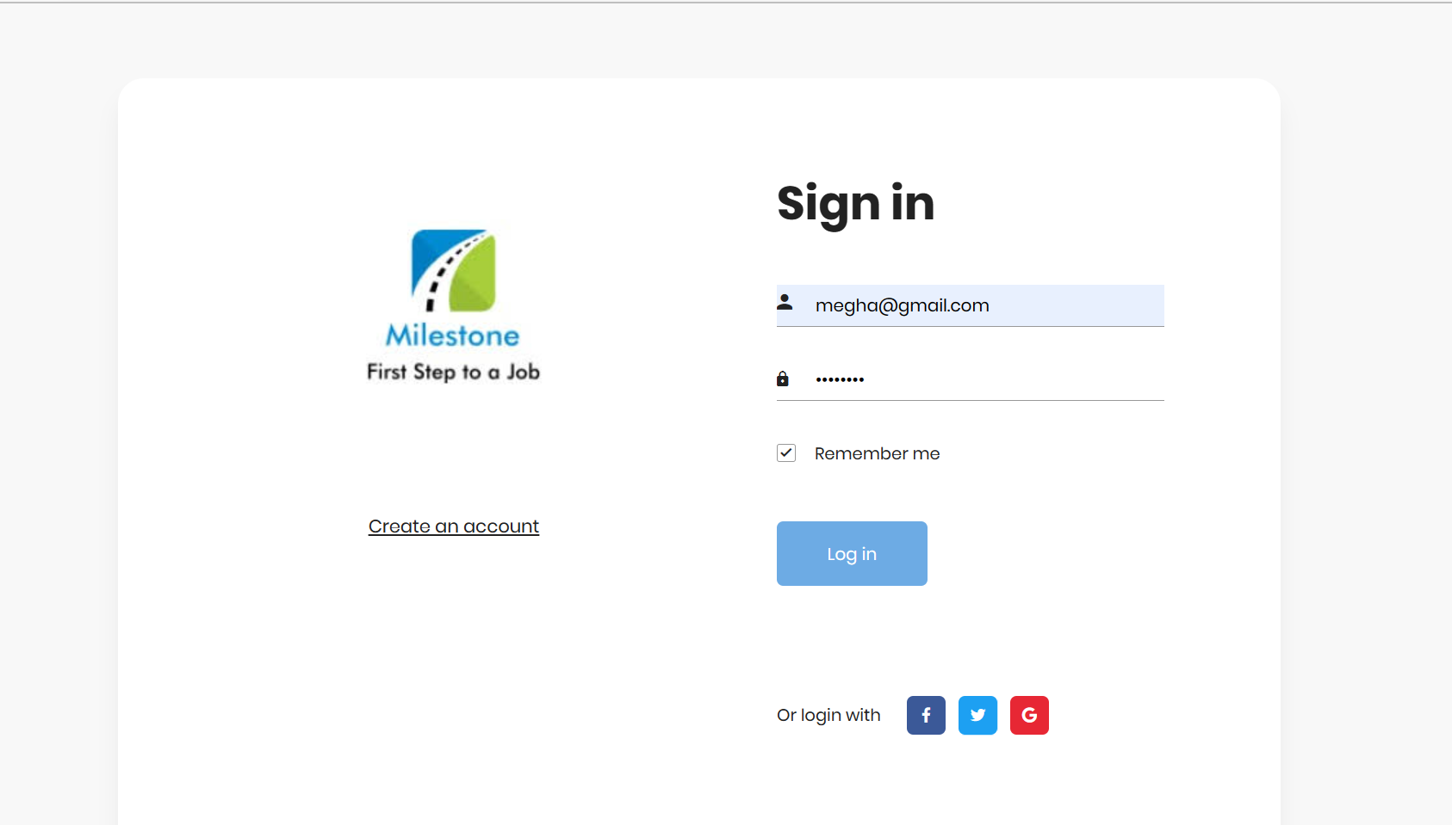

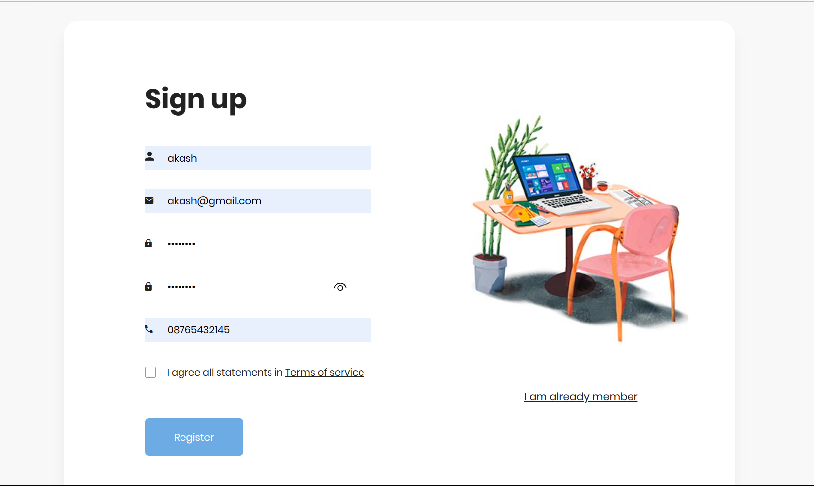

1. **Trainee Payment Form:**

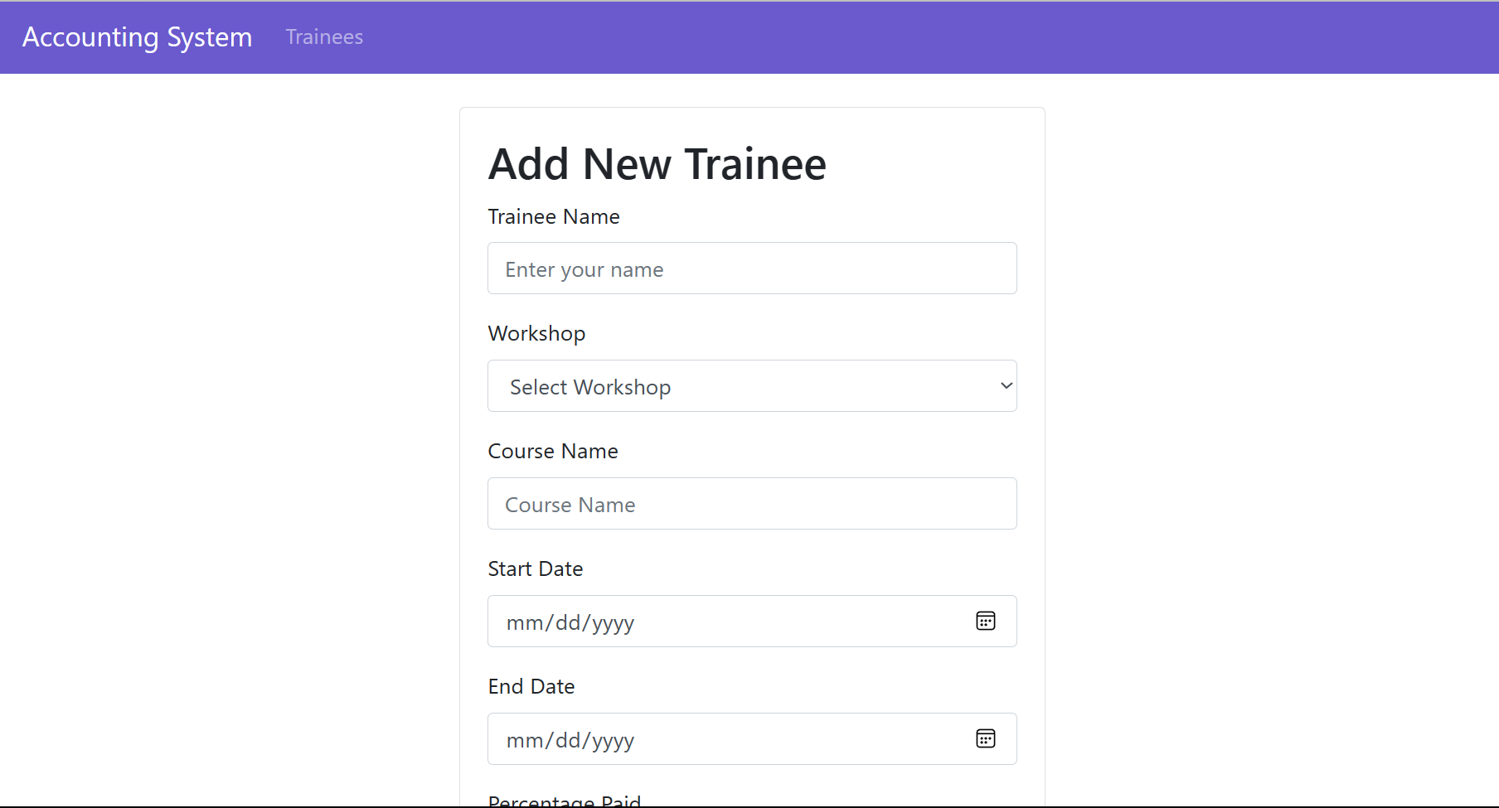

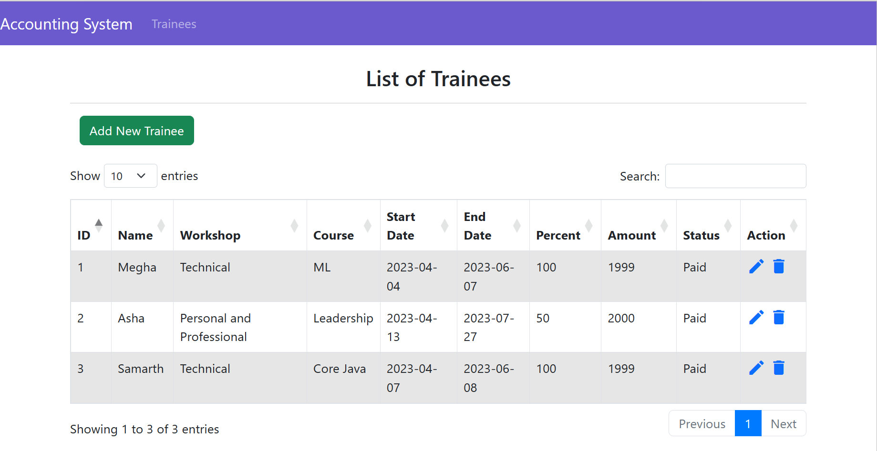

1. **Employee Payment Form:**

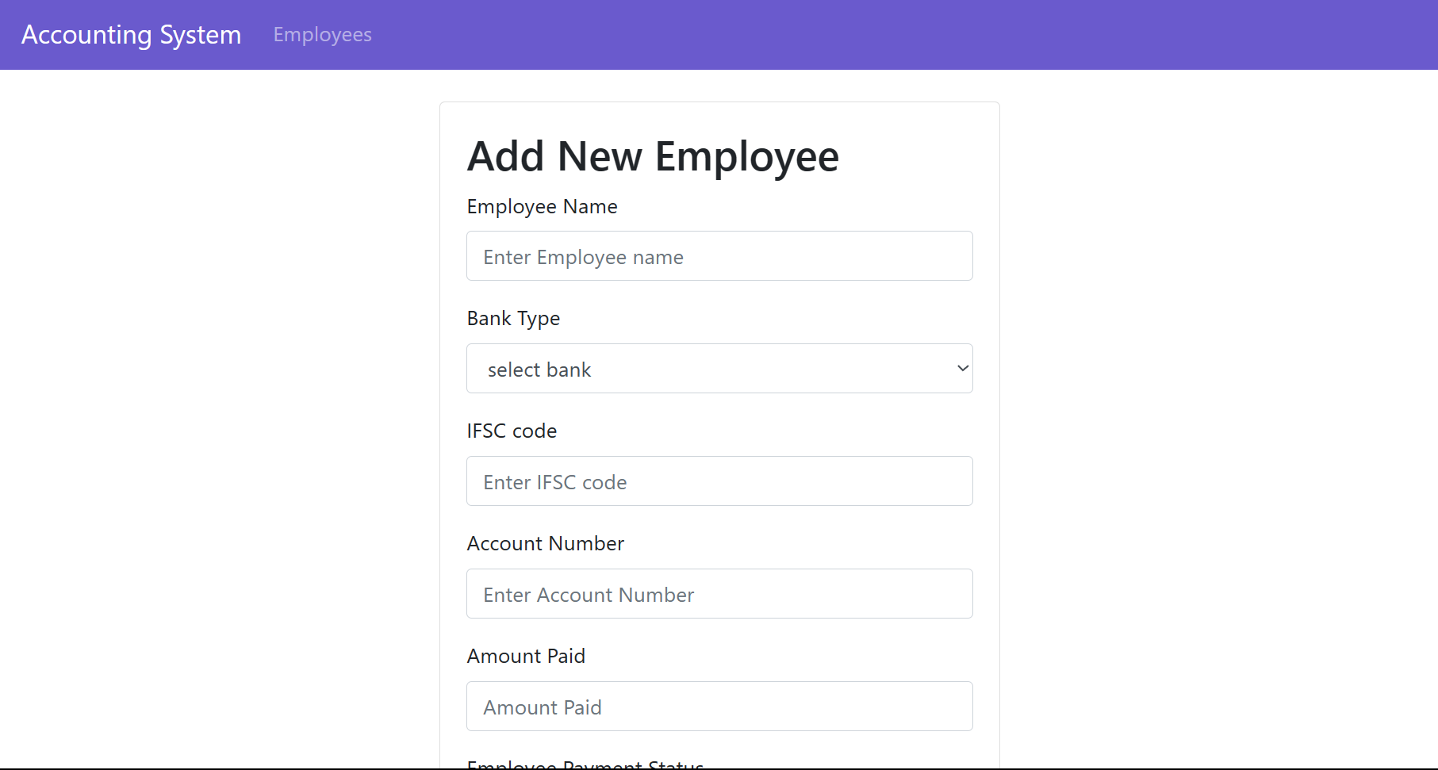

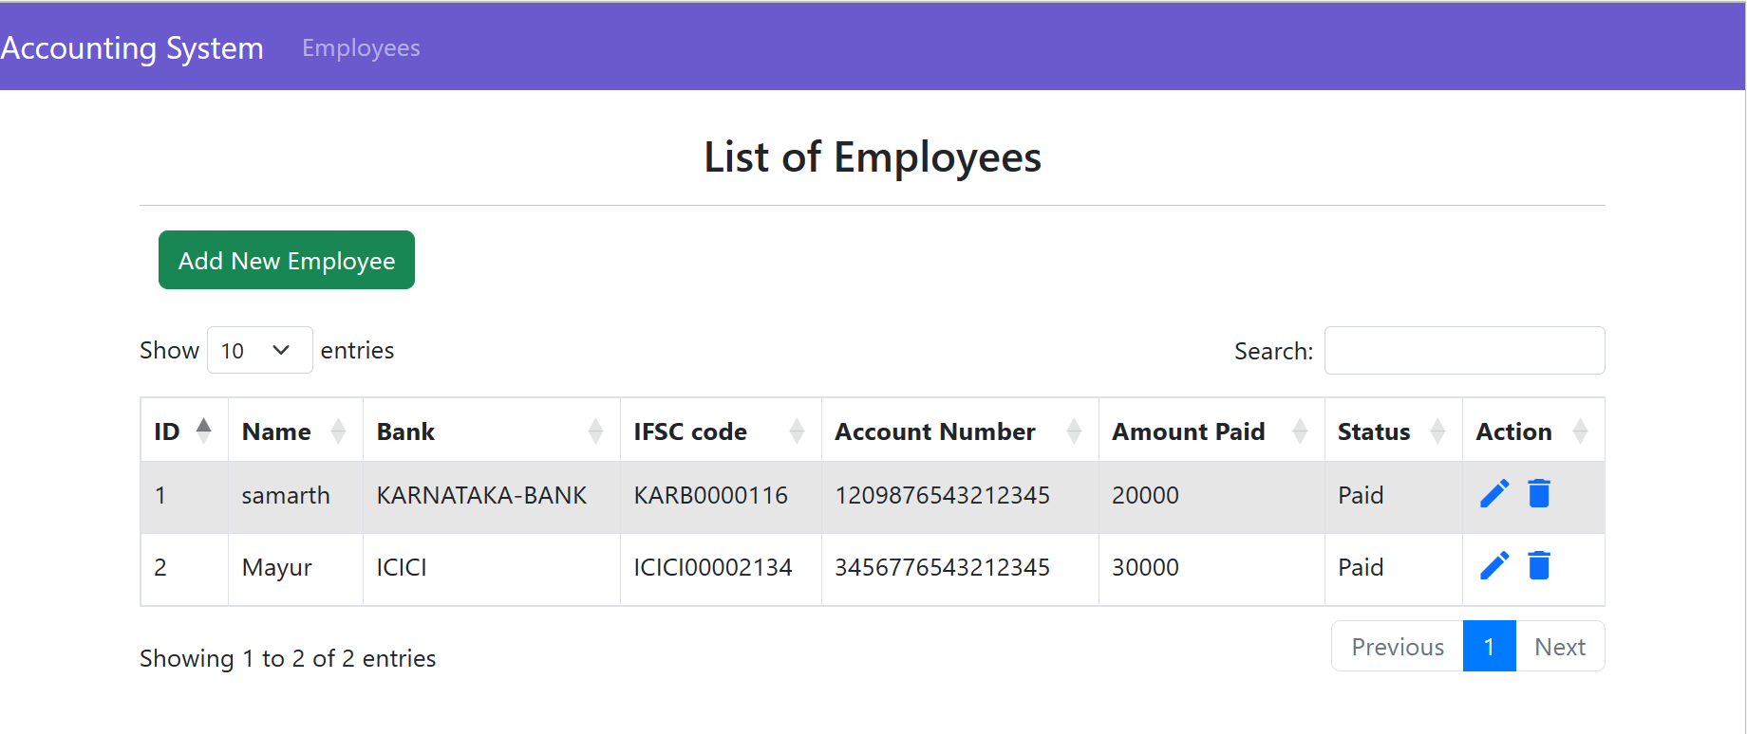

1. **CONCLUSION**

Practical knowledge means the visualization of the knowledge, which we read in our books. For this, we perform experiments and get observations. Practical knowledge is very important in every field. One must be familiar with the problems related to that field so that he may solve them and become a successful person.

After achieving the proper goal in life, an engineer has to enter in professional life. According to this life, he has to serve an industry, may be public or private sector or self-own. For the efficient work in the field, he must be well aware of the practical knowledge as well as theoretical knowledge.

Due to all above reasons and to bridge the gap between theory and practical, our engineering curriculum provides a practical training of 8 weeks.

During this internship period in the industry and get well all type of experience and knowledge about the working of companies and real time projects. I have undergone my 8 weeks of internship at Milestone First Step to Join. This report is based on the knowledge, which I acquired during these 8 weeks and knowledge acquired during my academics.

1. **REFERENCE**

* <https://www.w3schools.com>
* [www.javatpoint.com/java](http://www.javatpoint.com/java)
* <https://dev.mysql.com>
* http://tomcat.com